**DAY 3 ASSIGNMENT - 2**

**SOFTWARE TESTING:**

Software Testing is the process of evaluating a software application to find out whether it works as expected and to catch any bugs, errors, or missing requirements. It is basically like *checking if a product does what* it is *supposed to do* before releasing it to users.

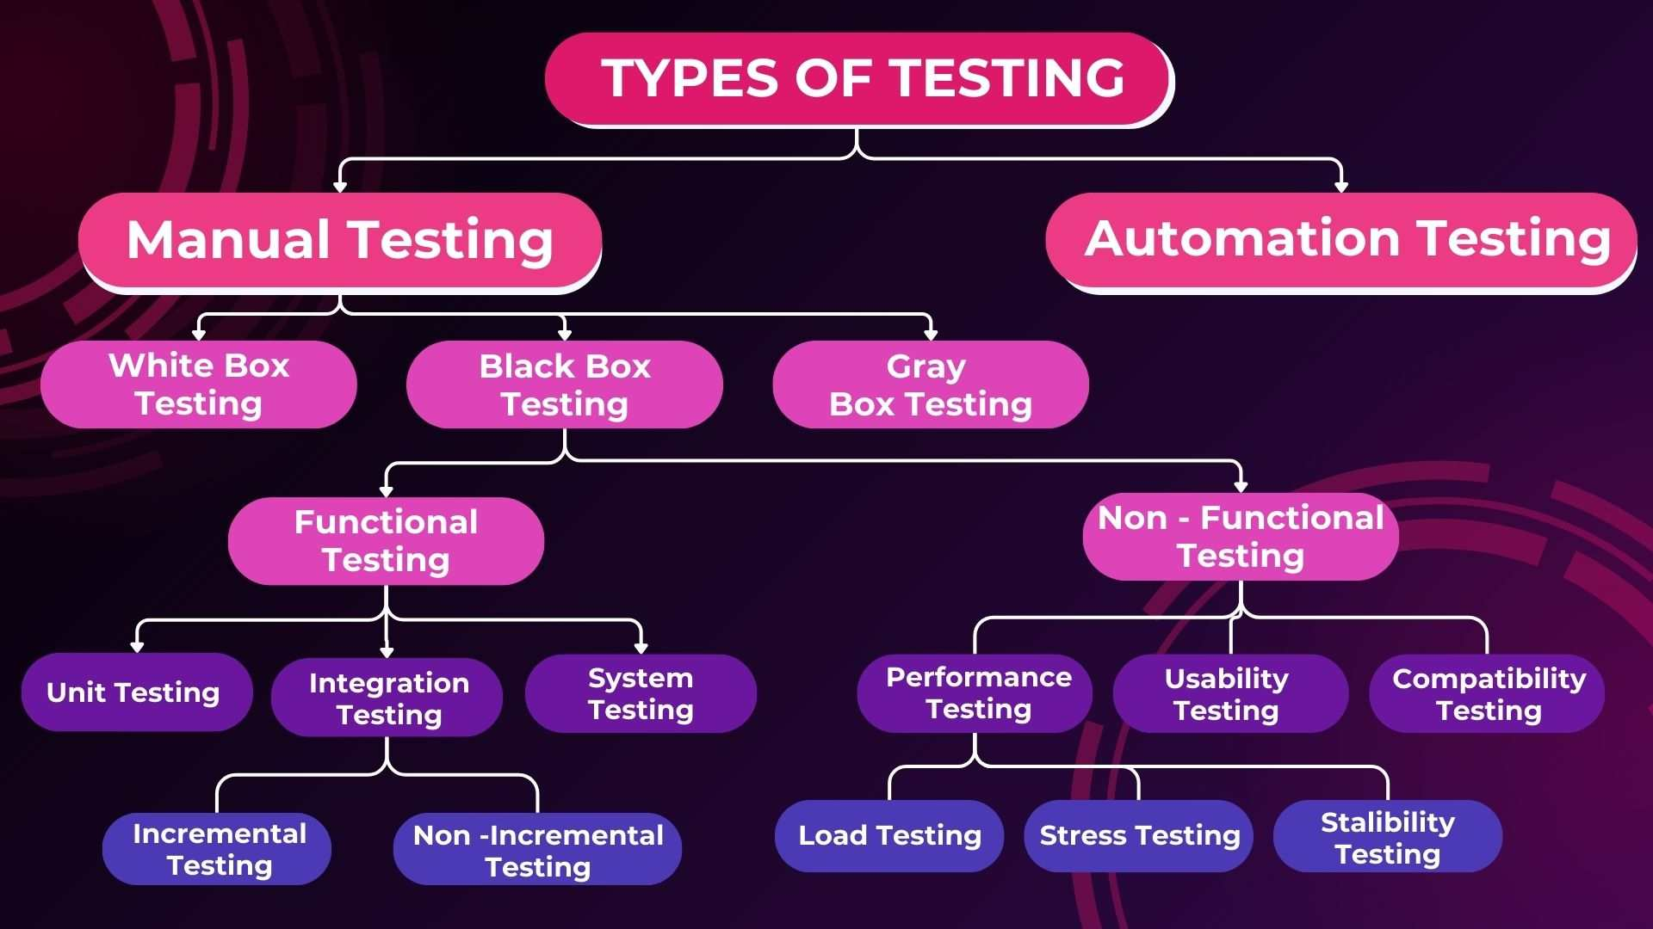

**Advantages of software testing**:

1. Improves Software Quality
2. Reduces Development Costs
3. Ensures Customer Satisfaction
4. Enhances Security
5. Prevents Failures
6. Facilitates Smooth Maintenance
7. Ensures Compliance
8. Improves Performance
9. **Unit Testing**

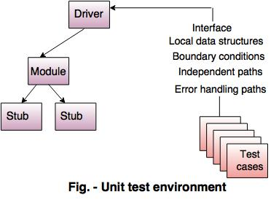

* Unit Testing is the process of testing the smallest testable parts of an application individually and independently.
* Each function, method, or class is tested to ensure it performs as expected.
* Developers usually perform unit testing during the development phase.
* **Goal:** Catch bugs early by testing individual units.
* **Example:** Testing a function that calculates the total bill amount including tax.
* **Tools Used:** JUnit (Java), NUnit (.NET), PyTest (Python), Jasmine (JavaScript)
* **Benefits:** Faster debugging, improves code quality, makes future changes safer.

1. **Integration Testing**

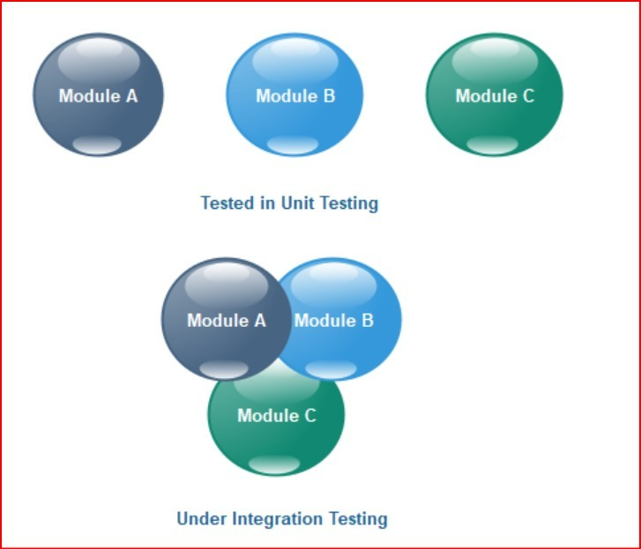

* After unit testing, integration testing checks how different modules or components work together.
* Even if units are correct individually, they might fail when combined due to interface or communication issues.
* **Goal:** Verify that the integrated components interact correctly.
* **Example:** Testing the interaction between a login page and the database that stores user credential.

**Approaches:**

* **Top-Down:** Test top modules first, then move downward.
* **Bottom-Up:** Start testing with the lower modules first.
* **Big Bang:** Integrate all components and test everything at once (less preferred because it's hard to find where the issue is).

**Tools Used:** JUnit (for integration), Postman (for API testing), SoapUI.

1. **System Testing**

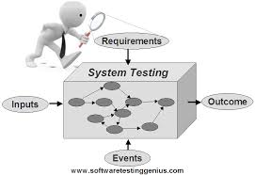

* System Testing validates the complete and fully integrated software system.
* It is performed in a similar environment to production.
* It involves functional and non-functional testing (performance, security, etc.).
* **Goal:** Confirm that the entire system meets the specified requirements.
* **Example:** Testing a full e-commerce platform — searching for products, placing an order, and making payment.

**Types inside System Testing:**

* Functional Testing (features)
* Performance Testing (speed and stability)
* Security Testing (protection against attacks)
* Usability Testing (user-friendliness).

**Tools Used:** Selenium, LoadRunner, JMeter.

1. **Acceptance Testing**

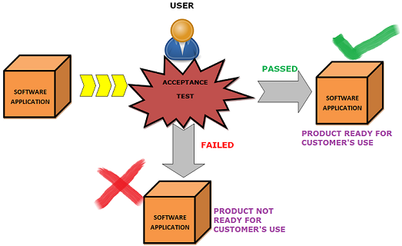

* Acceptance Testing is performed to determine whether the system is ready for delivery.
* It ensures that the software satisfies business requirements and the needs of the user or customer.
* **Goal:** Make sure the software works according to customer expectations.
* **Example:** A client tests a banking application to check if money transfers and balance checking work as expected before final approval.

1. **Regression Testing**

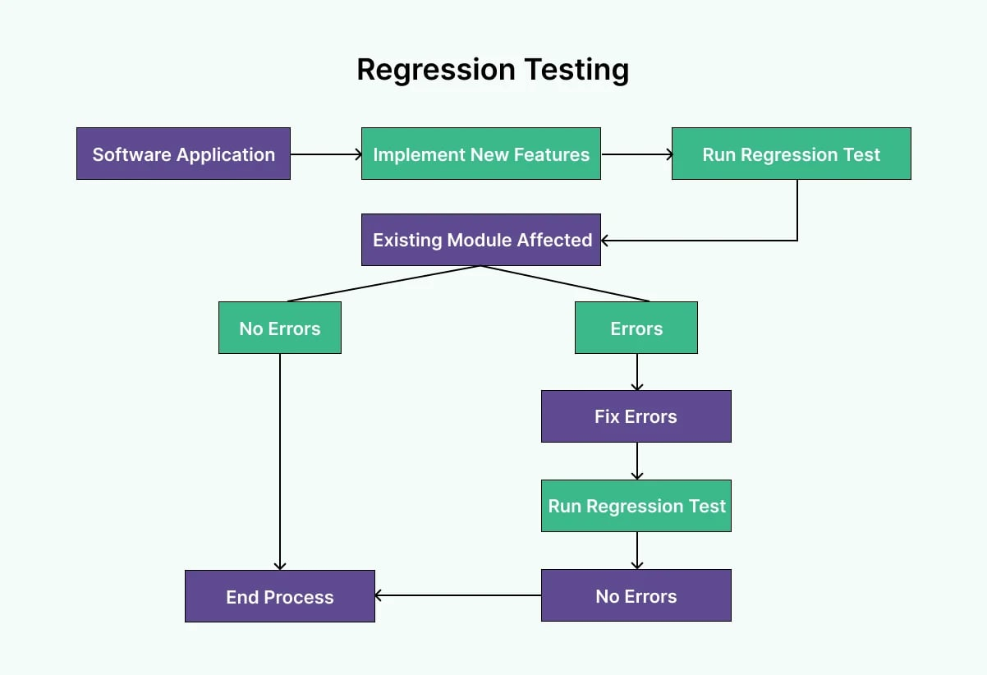

* Regression Testing is done after code changes (like enhancements, patches, or bug fixes) to ensure that existing functionality still works correctly.
* It helps detect side effects caused by new changes.
* **Goal:** Ensure that new updates do not break old features.
* **Example:** After adding a new discount feature to an online store, regression testing checks if the checkout and payment processes still function correctly.
* **Types of Regression Testing:**

**Partial Regression:** Test only the affected areas.

**Full Regression:** Test the entire system.

* **Tools Used:** Selenium, QTP, Test Complete, JUnit.